1. Which company is making the highest profit - Black Cab or Red Cab?

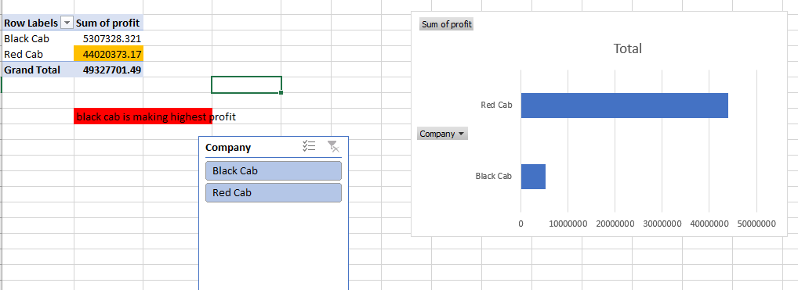

1. Which company is performing well over a period, regardless of which year it is?

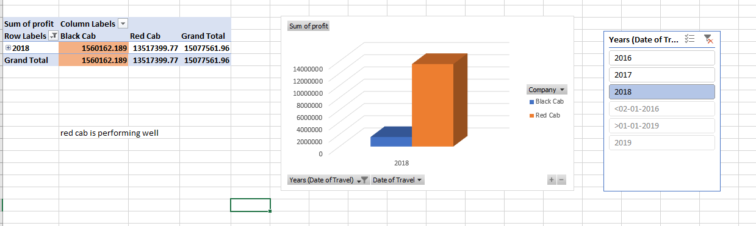

1. Find the top 10 customers in terms of Income and identify the highest profitable customer.

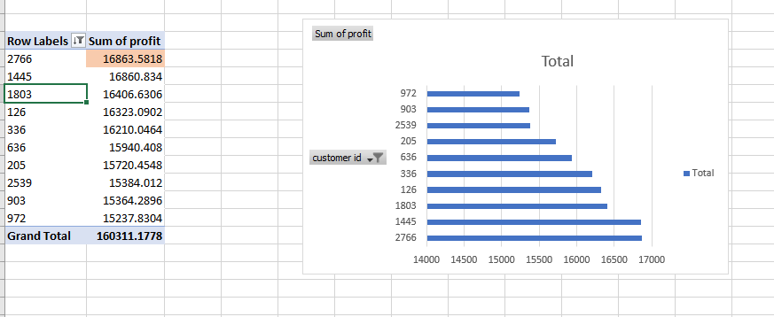

1. Which gender (male or female) records the greater number of travels?

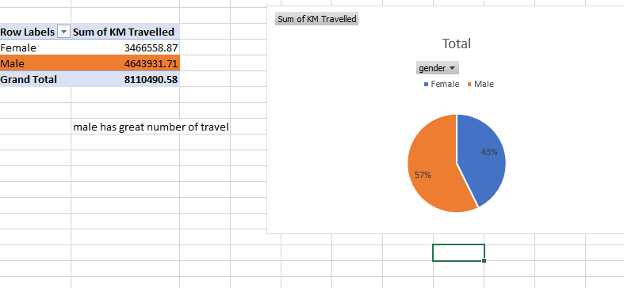

1. Which income group has a greater number of travellers? Make this analysis dynamic by adding slicers.

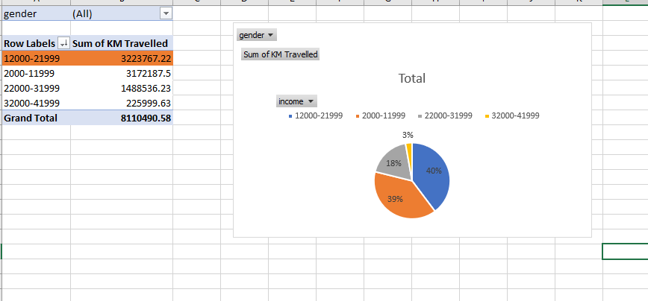

1. Did people prefer to pay by cash or card in Red Cab company in the year 2018?

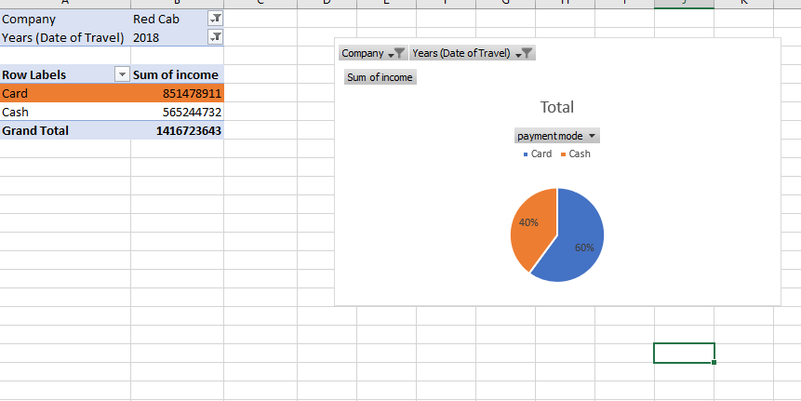

1. Which age group has less willingness to travel on cabs?

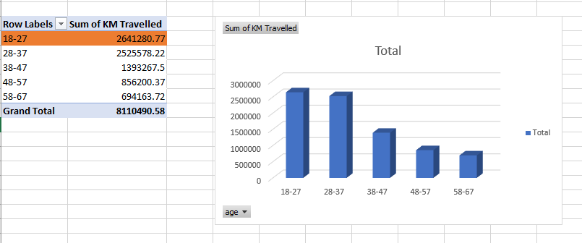

1. Which gender, age group, and income group people travel more in the cab?

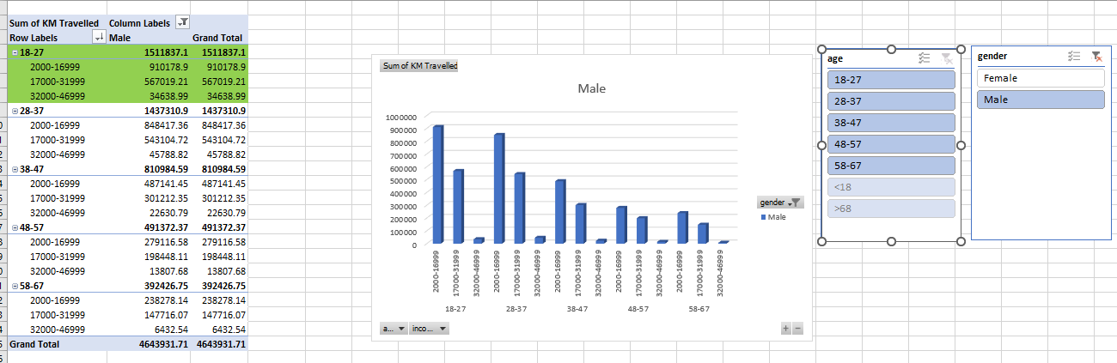

1. Create a profitability dashboard across the demographics.

